Project Identification

Project Name:
E-Wallet Transaction Monitoring System

Current Problem:
- Difficulty monitoring a large number of e-wallet transactions.
- Difficulty identifying suspicious or unusual financial transactions.
- Time-consuming manual transaction tracking and reporting.
- Risk of unauthorized transactions and potential financial fraud.

Description about project:
- The E-Wallet Transaction Monitoring System is designed to monitor and analyze electronic wallet transactions efficiently. The system stores transaction details, including Transaction ID, User ID, transaction amount, date, time, type, and status. It enables users or authorized monitoring staff to search for and track transactions easily using the Transaction ID or User ID. The system analyzes transaction data to identify suspicious or unusual activities based on predefined monitoring rules. It also generates reports and summarizes transaction information, helping monitoring staff review transactions more efficiently. The system aims to reduce manual effort, improve accuracy, enhance transaction monitoring, and support the early detection of potentially fraudulent activities. It also helps protect sensitive financial information through appropriate access controls and data security measures.

System Request
System Request — E-Wallet Transaction Monitoring System

Project Sponsor: | Eng/Eman
Business Need: | - Monitor a large number of e-wallet transactions efficiently.  - Reduce the risk of unauthorized transactions and potential financial fraud.  - Identify suspicious or unusual transactions as early as possible.  - Reduce the time and effort required for manual transaction monitoring and reporting.
Business Requirements: | - Store and update e-wallet transaction records.  - Provide search and tracking features using Transaction ID or User ID.  - Identify suspicious transactions based on predefined monitoring rules.  - Generate reports and summaries of transaction activities.
Business Value: | - Improve transaction monitoring and visibility.  - Save time by reducing manual transaction reviews.  - Reduce administrative costs and manual effort.  - Support the early identification of potentially fraudulent activities.
Special Issues or Constraints: | - The project must be completed by the agreed deadline.  - Transaction data must be updated accurately and consistently.  - Sensitive financial information must be protected through appropriate access controls.  - The system must follow applicable data protection and security requirements.

Time Estimation

 | Planning | Analysis | Design | Implementation | total
Standard percentages | 15% | 20% | 35% | 30% | 100%
Estimated time based on planning time | Actual: 11 days | 16 days | 25 days | 22 days | 74 days

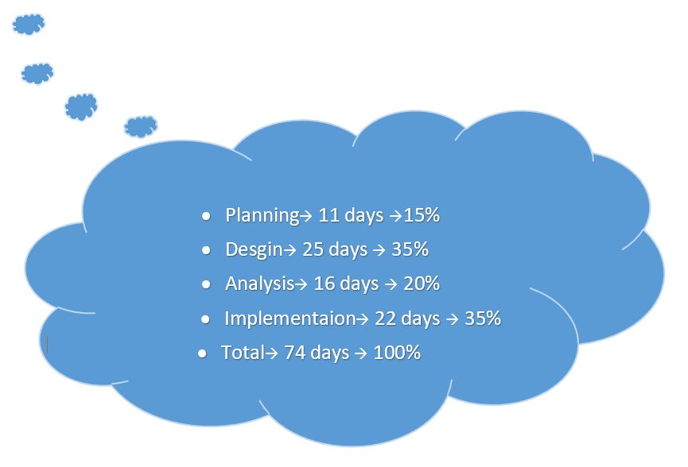

Selected Methodology: Agile Methodology

Reasons for Selecting Agile Methodology-:
The Agile methodology is selected for the E-Wallet Transaction Monitoring System because it allows the system to be developed in small, manageable increments. The system can be divided into several modules, such as transaction management, transaction tracking, suspicious transaction detection, and report generation.
The main reasons for selecting Agile are:
- Flexibility: Agile allows the team to modify requirements and improve the system when necessary.
- Early Error Detection: Each module can be tested separately, helping the team identify and fix errors early.
- Incremental Development: The system can be developed step by step, with each module adding new functionality.
- Continuous Improvement: The team can review the results of each development stage and make improvements.
- Better Quality: Continuous testing and feedback help improve the system's reliability and ensure that it meets the project requirements.

Tasks Identification
System Request | Name of Task
30/9/2026 | Start Date
1/10/2026 | End Date
Laila,Raneem | Person assigned to task
High | Priority
Microsoft word | Resources Needed
2days | Estimated Time
1 day | Actual Time

Feasibility Study | Name of Task
3/10/2026 | Start Date
7/110/2026 | End Date
Nada,nour | Person assigned to task
High | Priority
Microsoft Excel | Resources Needed
5days | Estimated Time
3 days | Actual Time

Pert Chart, Grantt Chart | Name of Task
21/10/2026 | Start Date
2/11/2026 | End Date
Laila,Raneem,Nada Mohamed,nada Hany,Nour | Person assigned to task
High | Priority
Canava App | Resources Needed
11days | Estimated Time
6 days | Actual Time

Interview | Name of Task
19/11/2026 | Start Date
24/11/2026 | End Date
Laila,Raneem,Nada Mohamed,nada Hany,Nour | Person assigned to task
Medium | Priority
Microsoft word | Resources Needed
16 hours | Estimated Time
14 hours | Actual Time

Questionnaire | Name of Task
19/11/2026 | Start Date
23/11/2026 | End Date
Laila,Raneem,Nada Mohamed,nada Hany,Nour | Person assigned to task
medium | Priority
Form drive | Resources Needed
5 hours | Estimated Time
2 hours | Actual Time

Data Flow Diagram | Name of Task
24/11/2026 | Start Date
29/11/2026 | End Date
Laila,Raneem,Nada Mohamed,nada Hany,Nour | Person assigned to task
High | Priority
Internet | Resources Needed
1 day | Estimated Time
18 hours | Actual Time

Data Store | Name of Task
29/11/2026 | Start Date
2/12/2026 | End Date
Nada Hany,Nada Mohamed | Person assigned to task
High | Priority
Microsoft word | Resources Needed
1 day | Estimated Time
17 hours | Actual Time

process specification | Name of Task
29/11/2026 | Start Date
3/12/2026 | End Date
Laila,Nour | Person assigned to task
High | Priority
Microsoft word | Resources Needed
1 day and 10 hours | Estimated Time
19 hours | Actual Time

Entity Relationship | Name of Task
2/12/2026 | Start Date
6/12/2026 | End Date
Raneem,Nada Mohamed | Person assigned to task
High | Priority
StarUML | Resources Needed
1 day and 10 hours | Estimated Time
19 hours | Actual Time

Normalization | Name of Task
2/12/2026 | Start Date
6/12/2026 | End Date
Laila,Nada Hany,Nour | Person assigned to task
High | Priority
StarUML | Resources Needed
1 day and 10 hours | Estimated Time
19 hours | Actual Time

design | Name of Task
7/12/2026 | Start Date
2/1/2026 | End Date
- | Person assigned to task
High | Priority
Visual studio code | Resources Needed
18 days | Estimated Time
13 days | Actual Time

Implementation | Name of Task
2/1/2026 | Start Date
24/1/2026 | End Date
Laila,Raneem,Nada Mohamed,nada Hany,Nour | Person assigned to task
High | Priority
Visual studio code | Resources Needed
16 days | Estimated Time
11 days | Actual Time



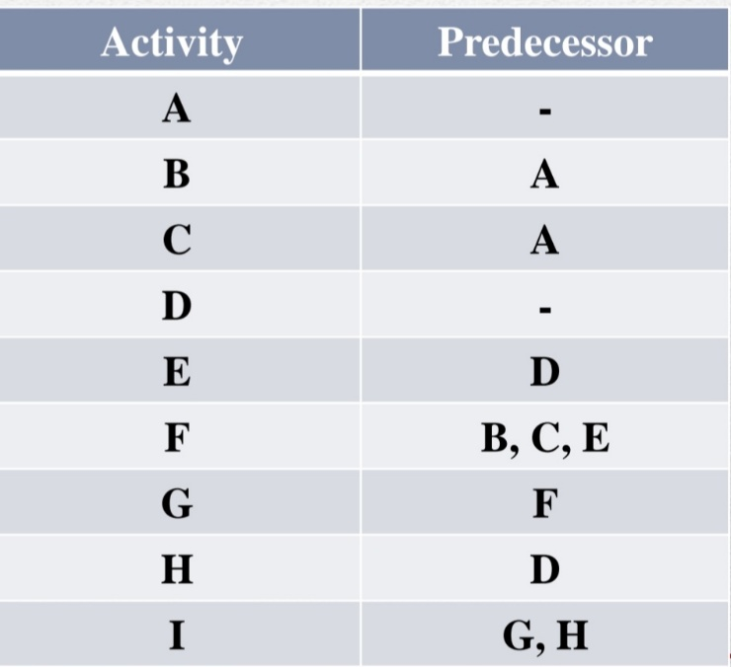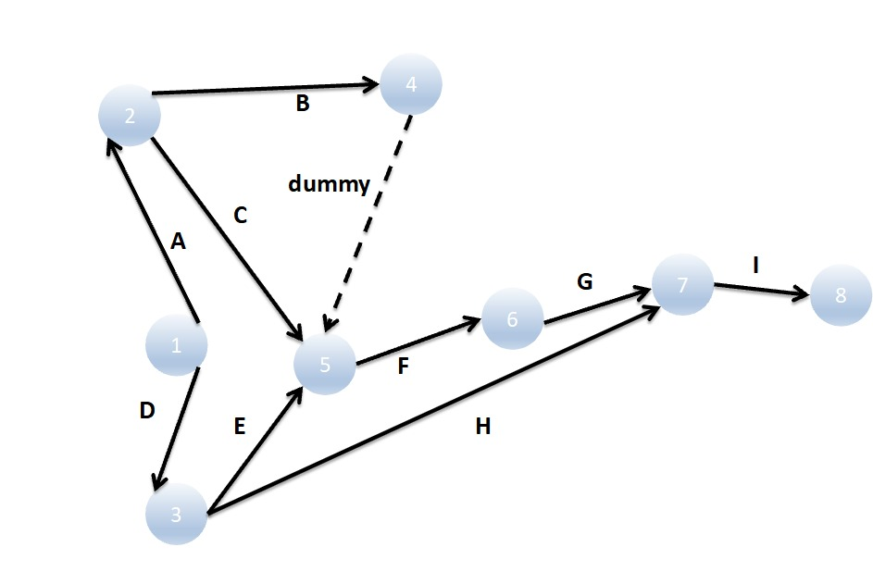

Task 1
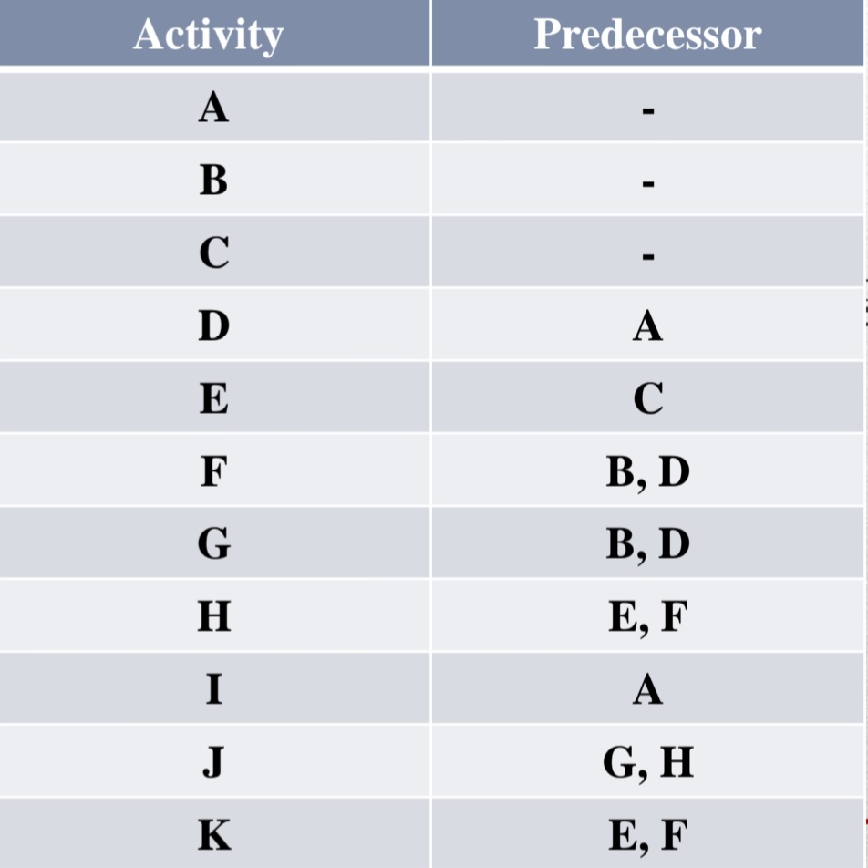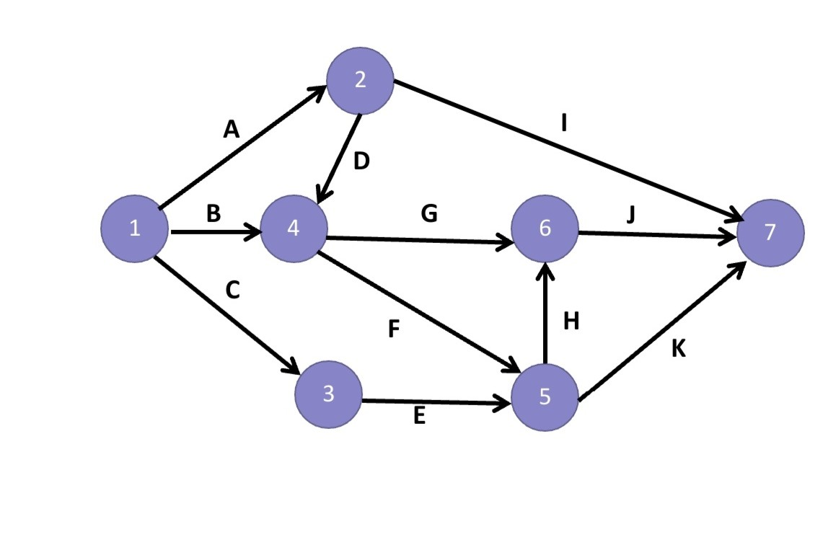
Task 2
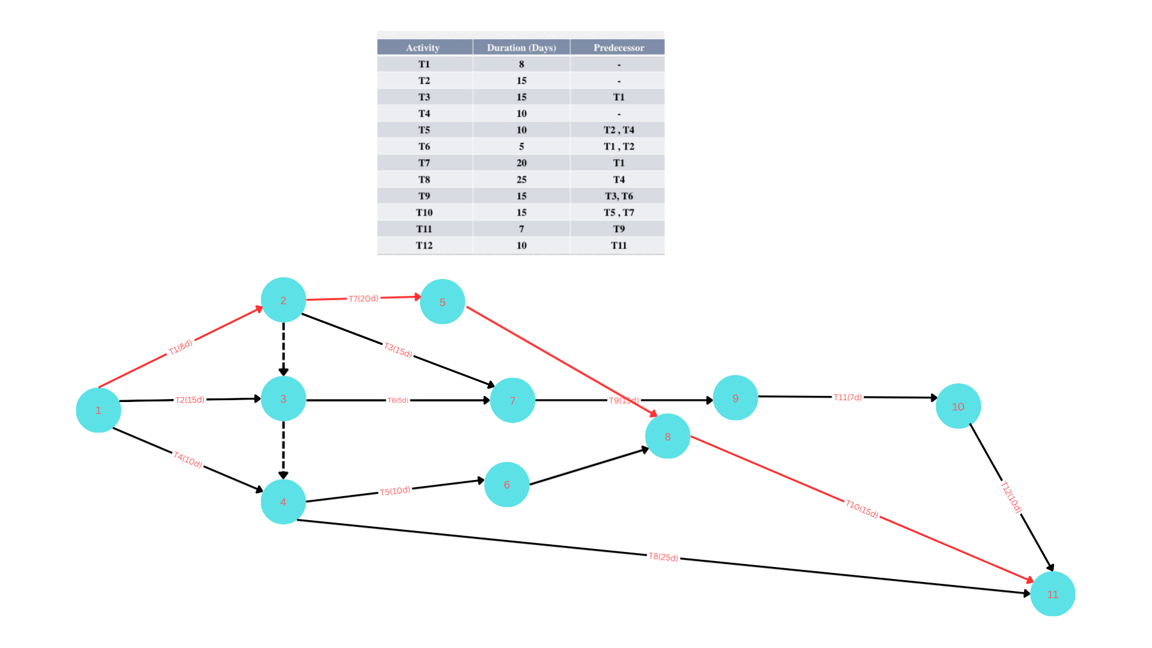

Task 3(pert chart)
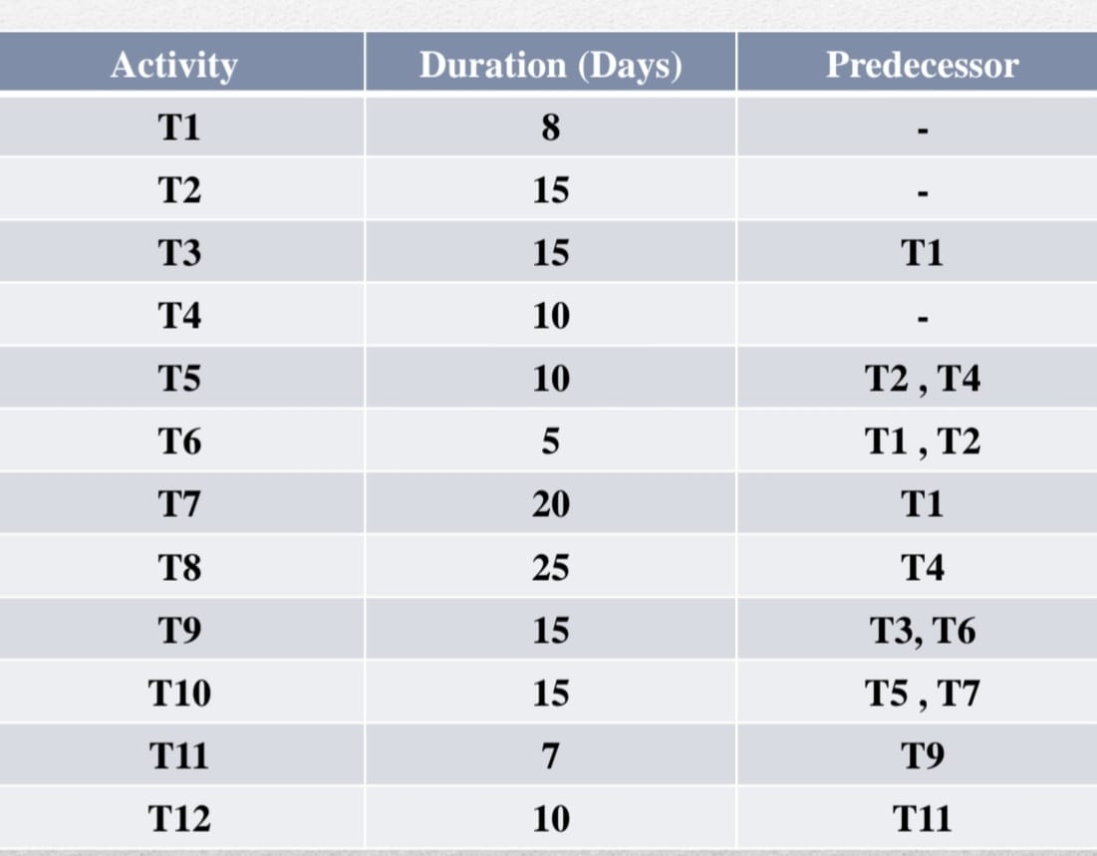

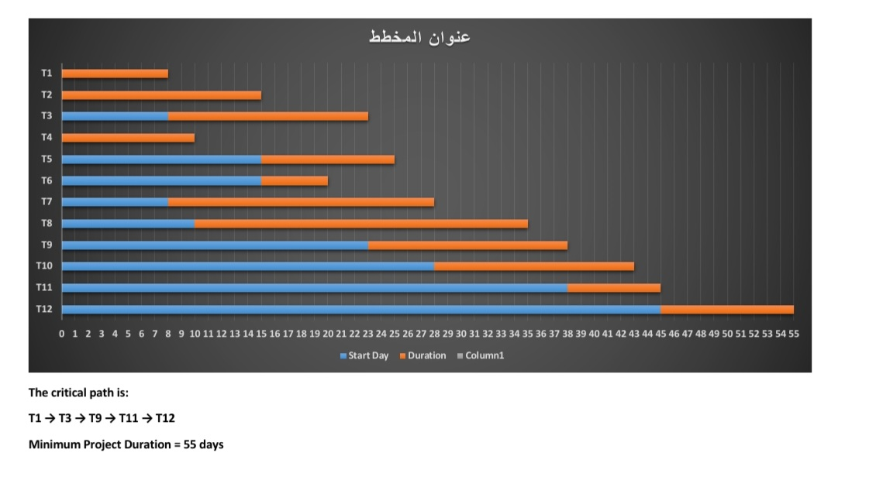
Task 3(Gantt chart)

